

Project and Professionalism (6CS007)

Literature Review

[Online Movie Ticket Booking System]

Student Id : 2357805 Student Name : Kushal Baniya Group : L6CG6
Supervisor : Sunam Shrestha
Reader : Deepson Shrestha
Cohort : 4
Submitted on : 01/02/2025

Acknowledgement

I would like to express my gratitude to the University of Wolverhampton and its affiliate Herald College Kathmandu (HCK) for providing me with the wonderful opportunity to write this report on Online Movie Ticket Booking Systems. I would also like to thank my supervisor, Sunam Shrestha, and my reader, Deepson Shrestha, for their invaluable guidance and support throughout the course of this project.

Abstract
Online movie ticket booking systems have made buying tickets quicker, easier, and more convenient compared to traditional methods. These systems let users check movie schedules, pick seats, and make secure payments from anywhere, at any time. For cinemas, they help manage operations more efficiently by handling seat bookings in real-time, reducing the need for ticket counters, and offering insights into customer preferences.
New technologies like artificial intelligence (AI) have made these systems even better by providing personalized movie suggestions, automating tasks, and improving efficiency. While they offer many benefits, challenges like ensuring security and making the system easy for everyone, including those less familiar with technology, still need to be addressed.

In the future, features like augmented reality (AR) for seat selection, social media integration for more engagement, and additional options like snack orders and discounts could make the experience even better. These improvements aim to keep up with new technology and make the system more useful for both customers and cinemas.

Table of Contents
- Introduction 1
- Academic Question 1
- Aims and Objectives 1
  - Aims 1
  - Objectives 1
- Literature Review 3
  - Usability analysis of the user interface of movie-related websites in terms of universal design 3
  - A CASE STUDY ON ONLINE TICKET BOOKING SYSTEM 3
  - A New approach for online movie ticket booking system 3
  - Design of Information System to Support Movie Ticket Booking and Cinema Operations 4
  - Enhancing User Experience in Online Movie Ticket Booking 4
  - Enhancing a Ticketing System with AI Intelligence 5
  - CUSTOMER PREFERENCE AND SATISFATION TOWARDS ONLINE MOVIE TICKET BOOKING SYSTEM 5
- Analysis of Findings 7
  - Usability and User experience 7
  - Impact on Cinema Operation: 7
  - Technological Advancements 7
  - Customer Satisfaction 7
  - challenges and solution 7
  - Future Direction 8
- Conclusion 8
References 9

Introduction
The creation of online movie ticket booking systems has become a crucial part of the modern movie industry, making it easier and faster for people to buy tickets. With the growth of technology, there is a greater need for simple, secure, and reliable online platforms, changing the way tickets are bought. This system allows customers to view movie listings, pick showtimes, and choose seats, all from their home or mobile phone. It also offers extra features like personalized suggestions, secure payment options, and 24/7 access, improving the overall experience for users.
For cinema operators, online booking systems bring benefits such as better efficiency and less reliance on physical ticket counters. As the movie industry embraces digital technology, these systems help make cinema operations smoother, manage seat reservations in real-time, and provide useful information about customer preferences and behaviors.

Aims and Objectives

Aims

The aim is to develop online movie ticket booking system that enhances the user experience by providing a seamless, efficient, and user-friendly platform for booking tickets across various devices and improve customer satisfaction by offering convenient features such as easy seat selection, secure payments, personalized recommendations, and 24/7 availability.

Objectives

    - To create an online movie ticket booking system that makes buying tickets easier, faster, and more convenient, while being easy to use on different devices and platforms.
    - To develop intuitive user interfaces to make the system easy to navigate for users unfamiliar with digital platforms.
    - To provide training programs for cinema staff and users on how to use the system effectively.

    - To integrate a performance monitoring system to analyze user adoption rates, identify challenges, and improve the system over time.
    - To adapt the platform to support other services like snack orders, movie reviews, and promotional offers for future scalability.
    - To make system that supports the local languages which makes user easy to use in rural area

4.1 Artefact

4.2 FDD:

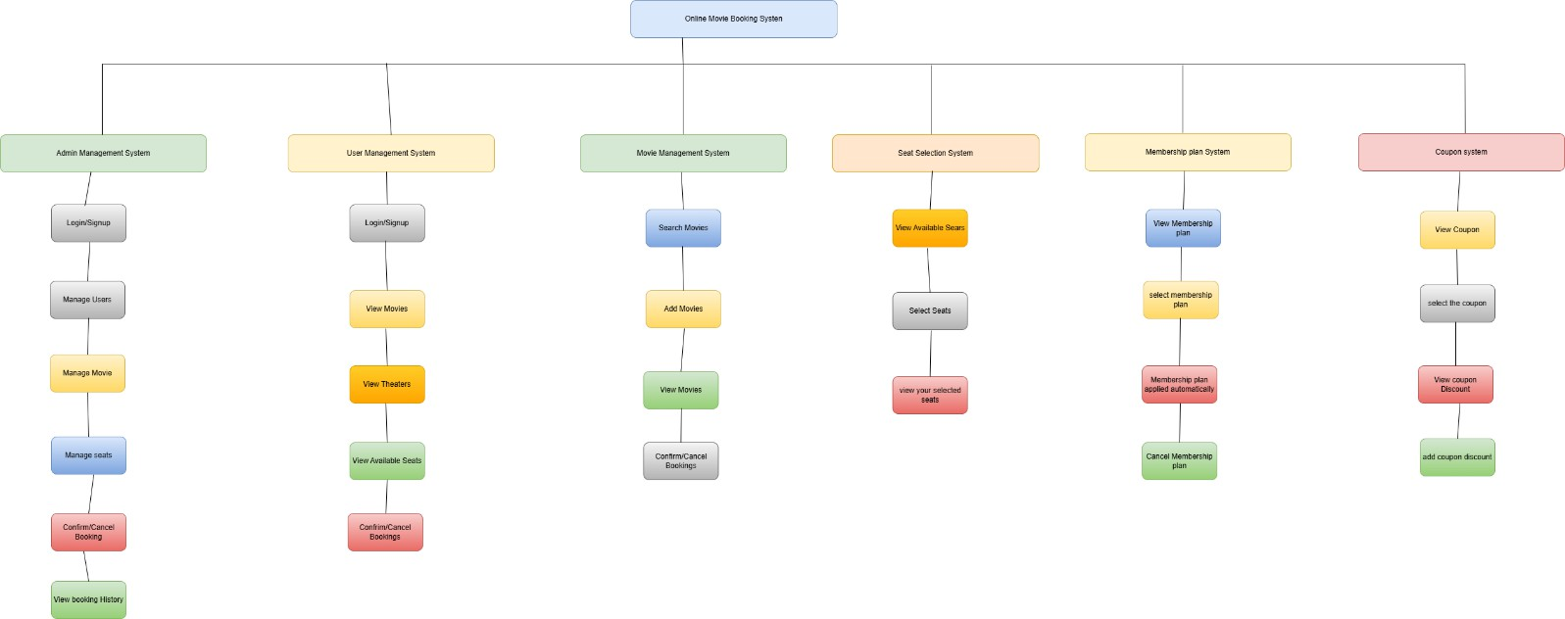

Figure 6: Functional decomposition diagram for the system

5.4.2. Overview of the System
Imagine developing an Online Movie Ticket Booking System—a platform where users can browse movies, book tickets, and enjoy exclusive membership benefits. The Functional Decomposition Diagram (FDD) acts as a blueprint, outlining the key functions and subsystems required for seamless operation.

At the highest level, the system's main objective is to "Create an Online Movie Ticket Booking System." To achieve this, the system is divided into multiple subsystems, each responsible for a specific function—just like different departments in a company working together to ensure smooth operations.

5.4.3. Breakdown of Each Subsystem
Below is an overview of the key subsystems and their functionalities:

1. Admin Management System (Blue)
This module is the control panel for administrators, enabling them to:

Login/Signup: Secure access for admins.

Manage Movies & Theaters: Add, edit, or remove movie listings and theater details.

Manage Showtimes & Seats: Set movie schedules and allocate seats.

Control User Access: Manage user accounts and assign roles.

Generate Reports: Analyze system usage and booking trends.

2. User Management System (Yellow)
This subsystem is for customers, allowing them to:

Signup/Login: Create accounts and access the platform.

View Profile: Check and update their personal details.

View Booking History: Track past and upcoming movie bookings.

Rate & Review Movies: Share feedback and ratings for watched movies.

3. Movie & Show Management System (Green)
This module is responsible for movie-related activities, such as:

Browse & Search Movies: Users can explore upcoming and currently available movies.

View Showtimes & Theaters: Check schedules and select preferred cinema locations.

Select Seats: Choose seats based on availability.

Book Tickets: Confirm movie bookings and receive digital tickets.

4. Membership System (Pink)
This subsystem manages memberships and exclusive offers, allowing users to:

Register for Membership: Enroll in a membership program.

Track Free Ticket Offers: Monitor eligibility for free tickets (e.g., 1 free ticket after 5 purchases).

Upgrade or Renew Membership: Extend membership benefits.

5. Coupon & Discount System (Light Orange)
This module handles promotions and discounts, providing functionalities such as:

Manage Coupons (Admins): Create and update discount codes.

View Available Coupons: Display active offers for users.

Apply Discounts: Use coupons during ticket bookings.

Track Coupon Usage: Monitor how frequently discounts are used.

6. Booking & Ticketing System (Purple)
This subsystem ensures smooth ticket reservations by allowing users to:

Select Showtimes & Seats: Pick a convenient movie time and preferred seating.

Confirm & Receive Tickets: Generate and store digital tickets.

Cancel or Modify Bookings: Adjust reservations if needed.

I haven’t added payment system in a diagram I will update it after I have made the payment processing.

Academic Question
How has the implementation of online movie ticket booking systems transformed the traditional cinema ticketing process?
Online movie ticket booking systems have changed the way people buy movie tickets, making it much easier and faster. In the past, people had to go to the theater, stand in long lines, and buy tickets in person. Now, with online booking, they can choose movies, select seats, and book tickets from their phones or computers anytime. This system also makes payments safer, offers discounts and rewards, and gives a better experience for moviegoers. For theaters, it helps reduce costs, avoid mistakes, and track customer preferences to improve services. Other features like pre-ordering snacks, scanning digital tickets, and using less paper make things even more convenient. Overall, online booking has made watching movies easier, smarter, and more enjoyable for everyone.

5.6. Scope and Limitation of the project

4.1 Scope

What This Project Will Include:
- A simple and easy-to-use interface where users can browse movies, check seat availability, and book tickets without hassle.
- Online payment options such as eSewa, Khalti, and mobile banking to make transactions smooth and secure.
- A dashboard for theater managers to:
  - Add and update movie details.
  - Keep track of ticket sales.
  - Manage movie schedules efficiently.
- Secure storage of customer data, including ticket purchases and account details. Users will also be able to create accounts for a more personalized experience.
- Special features like promotional coupons, discount codes, and membership options to attract more customers and increase bookings.

What This Project Will NOT Include:
- It won’t support physical ticket printing or distribution.
- The platform is specifically designed for theaters in Nepal.
- It will not provide online movie streaming—it is only for booking tickets for theater screenings.

4.2 Limitations
- The project has a limited budget, which means some advanced features might not be included.
- There is a fixed time frame to complete the project, so some features may be given priority over others.
- With limited resources, the development process might take longer to complete.
- Technical challenges, such as server crashes due to high traffic, may occur when many users are using the system at the same time.

Literature Review

Usability analysis of the user interface of movie-related websites in terms of universal design
The user interface (UI) and user experience (UX) are crucial elements that significantly impact the performance of movie booking systems. A well-designed UI and UX can help reduce cognitive load, improve task efficiency and enhance the overall user experience when navigating the system. The study emphasizes the importance of intuitive design, responsiveness, and accessibility features to ensure a seamless booking process across various platforms.
Additionally, incorporating features such as personalized recommendations and an easy-to-use interface not only boosts the usability of the system but also increases user engagement and loyalty (Karol Bielec, Jakub Sokół, Maria Skublewska-Paszkowska, 2022).
A good movie booking system needs to be responsive, ensuring it works smoothly across devices like smartphones, tablets, and desktops, making it convenient for users wherever they are.
Accessibility features, such as screen reader support, adjustable text sizes, and high-contrast themes, ensure inclusivity for users with different abilities, broadening the platform’s reach. Personalized recommendations enhance the experience by suggesting movies, showtimes, or offers tailored to user preferences, making the platform more engaging. A simple, easy-to-use interface further ensures that users of all technical skill levels can navigate effortlessly,
completing tasks quickly and efficiently. By focusing on these aspects, movie booking systems can deliver greater satisfaction, attract more users, and build lasting loyalty.

A CASE STUDY ON ONLINE TICKET BOOKING SYSTEM
The article, "A Case Study on Online Ticket Booking System Project," by (Acharya, 2024), explains how an online movie ticket booking system works. The system allows users to easily buy movie tickets through a website. It is built using PHP and JavaScript for the back-end and HTML and CSS for the front-end. There are two main sections: one for administrators who can manage cinemas, movies, and showtimes, and one for customers who can browse movies, choose showtimes, and buy tickets. The article goes over how the system is designed, including the processes users follow, the way data is organized, and how different parts of the system interact. It also talks about how the system ensures a good user experience, with easy navigation and secure payment options. The research shows how this system can help both moviegoers and theater owners by providing features like movie lists, schedules, and ticket purchases. It also covers how the system is tested and how the data is managed. In summary, the article gives a clear overview of the online ticket booking system, its features, and how it benefits both users and theater managers.

A New approach for online movie ticket booking system

This article discusses a new system for booking movie tickets online. The goal is to make the process easier and faster by allowing people to book tickets from their computers or phones instead of going to the theater. The system allows users to choose movies, select seats, and cancel tickets if needed. It also helps theater owners by reducing the need for many staff members at the counter, as everything can be done online. The system provides useful details about movies, show times, and ticket prices, which can be managed by an admin. The system is available all day, every day, so customers can book tickets anytime. The article also introduces a feature where special users, called "prime users," can book more tickets during busy times, like holidays or when popular movies are released. Overall, this system makes booking tickets easier, saves time, and improves the experience for both customers and theater owners. The authors discuss the benefits of using technology to improve traditional movie ticketing methods (Arjun Kumar Mishra, Shashank Gupta, Rajeev Kumar, 2022).

Design of Information System to Support Movie Ticket Booking and Cinema Operations
The article discusses the creation of an online cinema ticket booking system designed to make the ticketing process easier for users and improve cinema management. The system uses a three-layer architecture: a React-based frontend for user interaction, a REST API backend for processing requests, and a database built with Entity Framework on the .NET platform. It allows users to check movie schedules, reserve or buy tickets, and manage their accounts. Administrators can update movie listings, track reservations, and analyze customer behavior. The system includes special features like loyalty points calculation and real-time seat availability tracking. By addressing issues like long queues and limited seating options, the system provides a modern, efficient solution to enhance user convenience and cinema operations. This work showcases the use of new technologies to meet current digital demands effectively (Sara Lazarevic, Tamara Zuvela, 2022).
The loyalty points program encourages users to book more often, helping build better customer relationships and increasing engagement. By solving problems like long queues at cinemas and difficulties with managing limited seating, the system improves the overall experience for users while helping cinema operators run their businesses more efficiently. This system shows how modern
technology can solve today’s challenges and provide benefits for both customers and businesses.

Enhancing User Experience in Online Movie Ticket Booking

The article discusses the design, development, and deployment of an online ticket booking system that focuses on improving the user experience. It highlights how online platforms have become crucial in the film industry, making ticket purchases easier for consumers. The paper covers important features like simple interface design, real-time seat availability, and secure payment methods. It also points out challenges such as ensuring the site works on different devices, keeping data up-to-date, and protecting users' payment details, and offers solutions to these problems (Vaidik Rao, Vansh Pratap, Rishabh Sharma, Jayshree Surolia, 2024).

The article suggests possible future improvements like adding augmented reality for seat selection, providing personalized movie suggestions, and integrating social media to make the user experience more engaging. While the article provides useful insights into usability and accessibility, it doesn’t go into much detail about the technology behind the systems or present much data to support its points. Despite these gaps, the article effectively shows how online booking systems have changed the movie industry and offers a strong base for future development in this field.

Enhancing a Ticketing System with AI Intelligence
The article explains how artificial intelligence (AI) is improving ticketing systems and customer service. It shows how AI can handle routine tasks like sorting, assigning, and solving tickets, making the process faster and reducing mistakes. AI uses machine learning to send tickets to the right agents based on their skills, availability, and the urgency of the request. It also uses tools like sentiment analysis to rank tickets by priority and offer personalized solutions, freeing up human agents to focus on more complicated issues.

The article explains the technical steps, like using past data, analyzing customer emotions, and applying language processing, to make ticketing systems more efficient. AI also helps businesses save time, cut costs, and manage more tickets as demand grows. While the article clearly shows the benefits of using AI, it could have discussed the challenges of setting up such systems. Overall, it offers useful information on how AI can make customer service faster, smarter, and more customer-friendly (Koka, 2024).

CUSTOMER PREFERENCE AND SATISFATION TOWARDS ONLINE MOVIE TICKET BOOKING SYSTEM
The article explores how people use online movie ticket booking systems and what influences their preferences and satisfaction. It highlights that feature like easy seat selection, 24/7 availability, and cashless payments make these systems convenient. The study shows that saving time and getting promotional offers are the main reasons customers prefer online booking. It also finds that factors like age, gender, income, and family size play a big role in how satisfied customers are. The article points out some common issues users face and suggests ways to improve the system. Overall, it emphasizes the growing popularity of digital booking and its impact on users' experiences (s.M. Yamuna, Mrs R Shiji, 2020).

The research also looks at how things like age, gender, income, and family size affect how satisfied users are. For example, younger users might care more about how fast and easy the system is, while families might be more interested in affordable prices and finding seats together. The study also points out common problems users face, like technical issues, payment problems, or difficulty using the platform, and suggests ways to improve the system to make it more reliable. In conclusion, the article highlights the growing popularity of online ticket booking systems and how they impact user experiences. It stresses the need to keep improving these platforms to meet different user needs and ensure high satisfaction, showing how much digital solutions are becoming a key part of the entertainment industry.

7. Project Methodology

7.2 Why SCRUM?
I’ve chosen SCRUM for this project because it works well with the changing nature of the online movie ticket booking system. Since the system involves things like user accounts, ticket booking, payment methods, and special offers, SCRUM helps by allowing regular feedback and the ability to make changes during the development process. This ensures that the platform can adapt quickly to what users want as the project moves forward.

SCRUM also focuses on delivering small, working features in short cycles or sprints. This means we can focus on important features like ticket booking and payment integration first. With a tight timeline and limited resources, SCRUM helps us prioritize the most important tasks to ensure we meet our deadlines and deliver a good product. Plus, SCRUM’s focus on teamwork and clear communication makes it easier for everyone to stay on the same page and solve problems quickly.

8. Different Technology and Tools used for the project

8.1 Why These Tools and Techniques?
I’ve chosen the MERN stack (MongoDB, Express.js, React.js, and Node.js) because it allows me to use JavaScript for both the frontend and backend. This makes development simpler, as I don’t have to switch between different languages. By using one language throughout, the team can focus on a single technology stack. The MERN stack is also scalable, which is important as the ticket booking system might have high traffic in the future.
- MongoDB is great for storing dynamic content like movie schedules, user profiles, and booking info, giving us the flexibility needed for the project.
- Express.js and Node.js are fast and lightweight, which is perfect for handling the real-time requests of a booking system.
- React.js helps create a smooth, interactive user interface, allowing users to make bookings easily with real-time updates.

8.2 Which Programming Language and Framework?
- Programming Language: I’m using JavaScript for both the frontend and backend, ensuring consistency across the entire project.
- Frontend Framework: React.js is used to build the user interface, making it fast and dynamic, with reusable components.
- Backend Framework: Express.js (running on Node.js) will handle the backend logic, managing APIs and connecting to the database.

8.3 Tools Used
- IDE: I’m using VS Code because it’s lightweight, highly customizable, and supports a lot of useful extensions for JavaScript, React, and Node.js development.
- GIT Client: For version control, I use Git to track changes in the code, and GitHub to manage the project remotely, ensuring collaboration and proper code backups.

8.4 Icon Package or Font
For icons, I’m considering using Font Awesome. It will make it easy to add commonly used icons (like those for bookings, payments, and user profiles) to the interface. As for fonts, I’ll likely go with Roboto or Open Sans to keep the text clean, readable, and modern.

8.5 Unit Testing and Mock Testing Frameworks
I’m using Postman to test the Express.js backend API endpoints. Postman helps me manually check the different routes, validate the responses, and ensure everything works as expected. This ensures that the backend functions correctly before going live, improving the quality of the system.

8.6 Package Manager
I’m using npm (Node Package Manager) to manage project dependencies, install packages, and keep track of versions. It’s ideal for a Node.js project and will help manage all the libraries and tools needed for the development.

9. Artefact Designs

9.1Admin management System

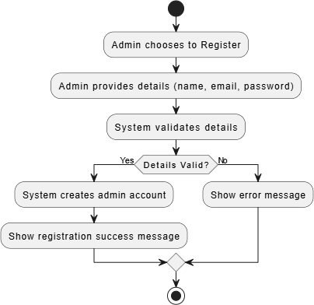

Figure 7: Activity diagram for admin registration
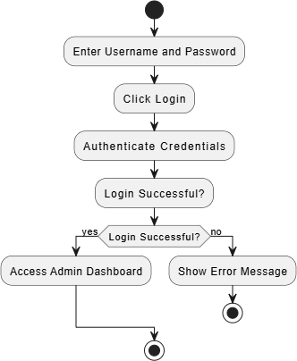

Figure 8: Activity diagram for admin login

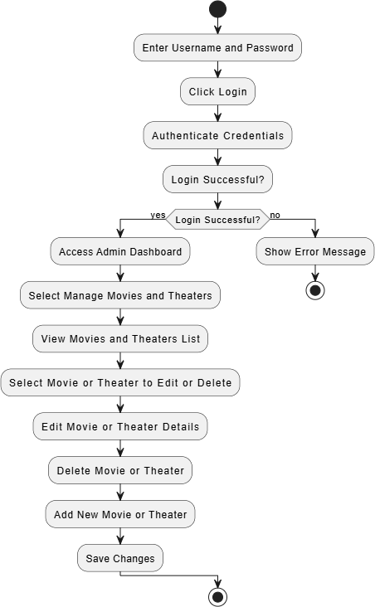
Figure 9: Activity diagram for managing movies and theater

Figure 10: Use case diagram for admin management system

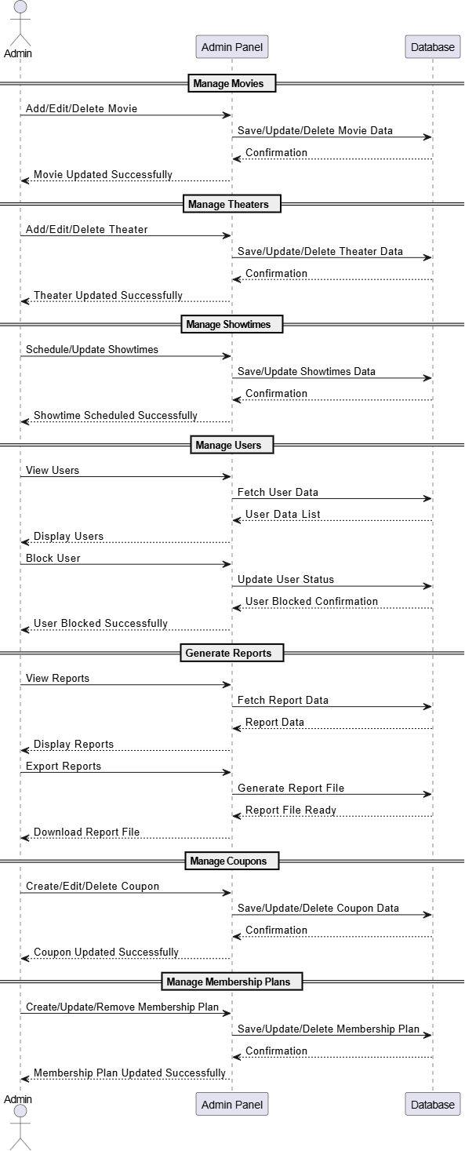
Figure 11: Sequence diagram for admin management system

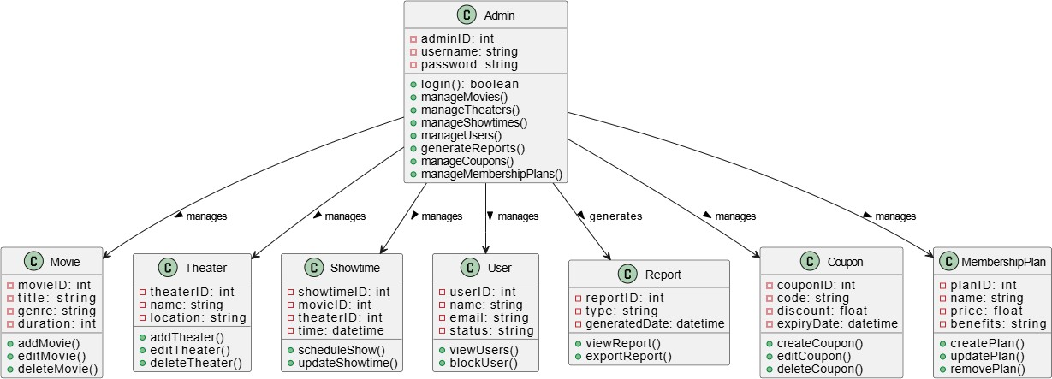

Figure 12: Class diagram for admin management system

9.2User Management System

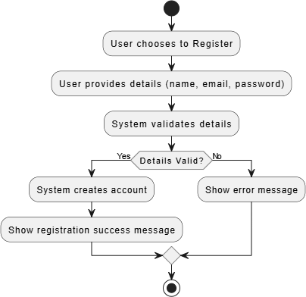

Figure 13: Activity diagram for user registration

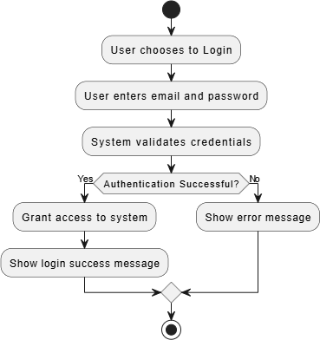
Figure 14: Activity diagram for user login

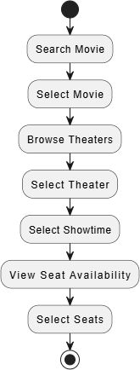
Figure 15: Activity diagram for user movie and theater

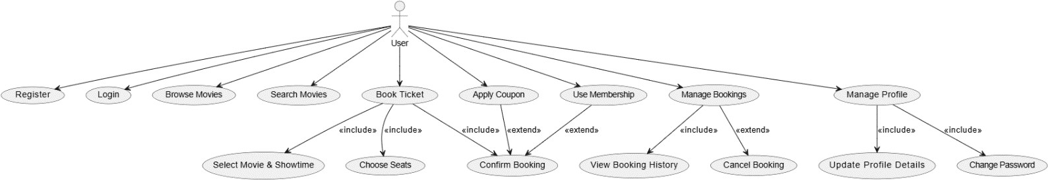

Figure 16: Use case diagram for user management system

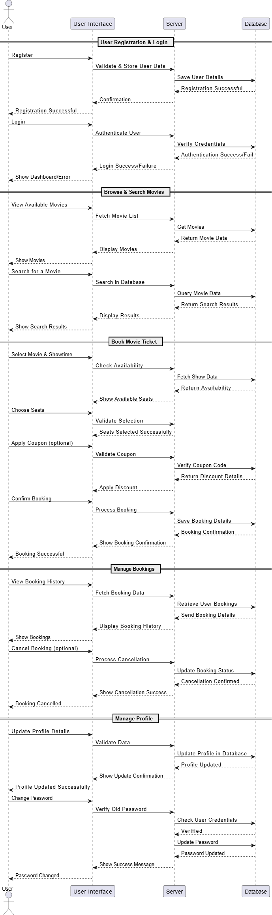
Figure 17: Sequence diagram for user management system

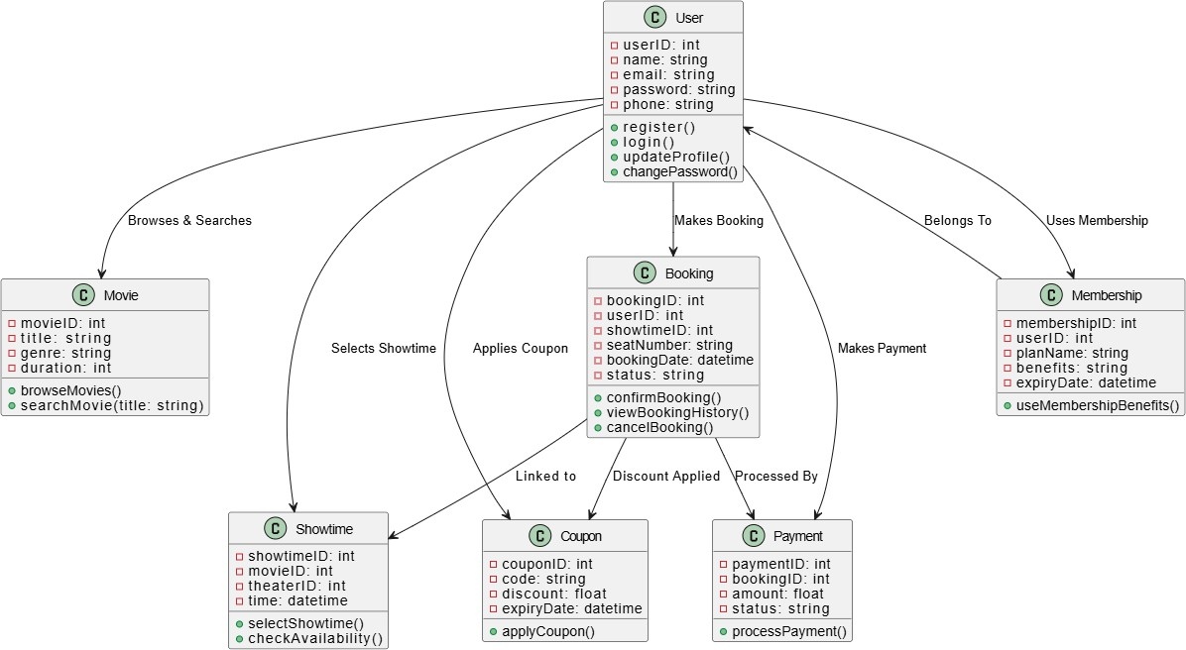

Figure 18: Class diagram for user management system

9.3 Movie Management System
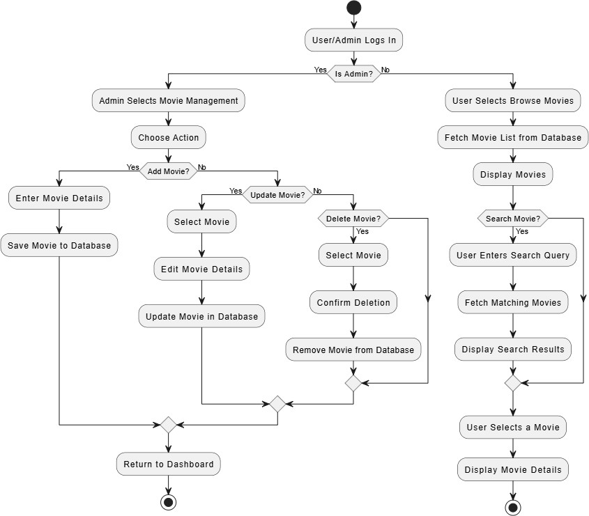

Figure 32: Activity diagram for movie management

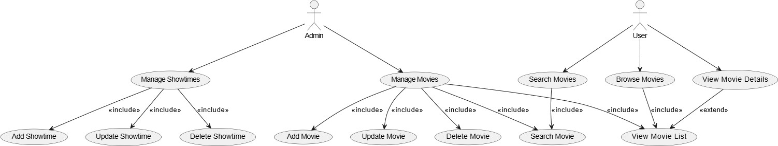

Figure 33: Use case for movie management

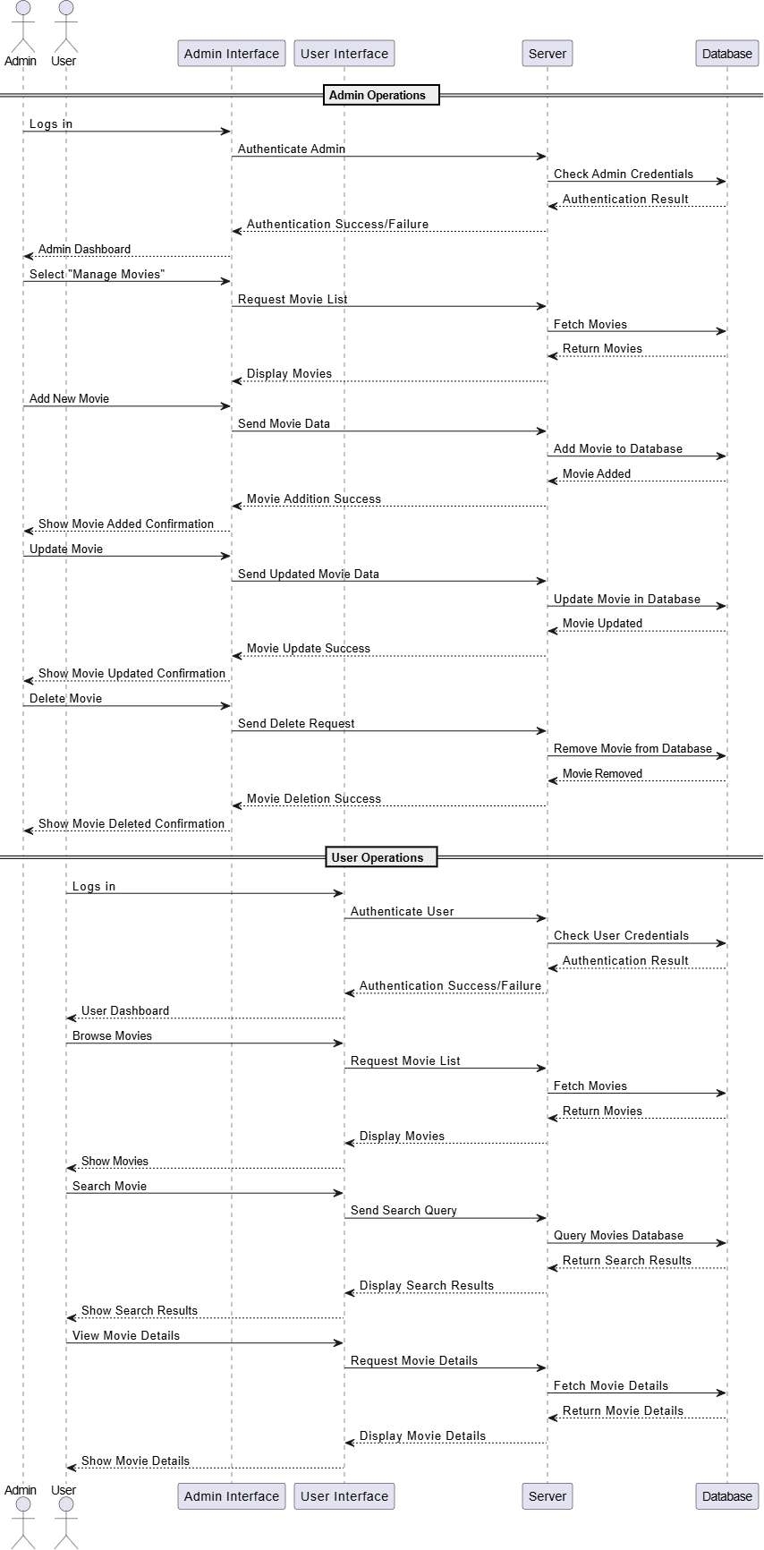
Figure 34: Sequence diagram for movie management

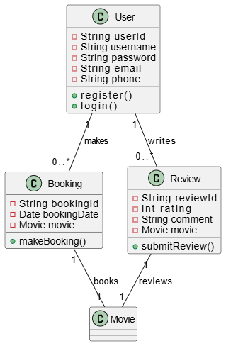

Figure: class diagram for admin movie management

Figure: class diagram for user movie management

Analysis of Findings

Usability and User experience:
A good user interface (UI) and user experience (UX) are very important for the success of online movie ticket booking systems. Research shows that a simple, accessible, and responsive design makes the system easier and more enjoyable to use (Karol Bielec et al., 2022). Features like easy seat selection and personalized suggestions not only make the system more user-friendly but also encourage people to use it more often. This shows how important it is to focus on making the system look good and work smoothly so users can easily find their way around.

Impact on Cinema Operation:
Switching to online systems has greatly improved how cinemas operate. With less need for physical ticket counters, cinemas can handle reservations and seat assignments in real-time, reducing wait times for customers and making operations run more smoothly (Sara Lazarevic, Tamara Zuvela, 2022). Features like loyalty points and real-time seat tracking help cinemas use their resources better and meet customer demand more efficiently. Additionally, tools for managing movie schedules and tracking ticket sales make it easier for cinemas to provide better service and improve overall management.

Technological Advancements:

Adding artificial intelligence (AI) to ticketing systems has made them work faster and more efficiently. AI can sort tickets, assign them automatically, and analyze customer emotions, which helps process tickets quickly and with fewer mistakes. It also personalizes the experience by suggesting movies based on what users have liked before (Koka, 2024). AI uses machine learning to prioritize tickets based on urgency or customer feelings, making the service more efficient and tailored. This shows how AI can improve both the user experience and the behind- the-scenes operations of movie ticketing systems.

Customer Satisfaction:

Online booking systems make customers happy by offering convenience. Features like easy seat selection, cashless payments, and 24/7 availability are key reasons why people prefer these systems (S.M. Yamuna, Mrs. R Shiji, 2020). Saving time, getting discounts, and booking tickets from home also make them more appealing. However, factors like age, gender, income, and family size affect satisfaction, showing that these systems need to be flexible to meet the needs of different users.

challenges and solution:

While online booking systems have many benefits, they also come with challenges. Some people, especially those less familiar with technology, may find it hard to use these systems. Clear instructions and easy-to-use designs are important to make them accessible for everyone

(Vaidik Rao et al., 2024). Security issues, like concerns about payment safety and data

protection, are also a big concern. To gain customer trust and prevent security problems, it’s crucial to improve secure payment systems and use strong data encryption methods.

Future Direction

The future of online movie ticket booking systems focuses on making the user experience even better with advanced features like augmented reality (AR) for choosing seats and personalized movie recommendations. Adding social media features and real-time interaction with other users could make the process more engaging and community-focused. These improvements aim to enhance the user journey and keep up with new technology trends in digital entertainment (Vaidik Rao et al., 2024).

Conclusion

Online movie ticket booking systems have changed the way people buy movie tickets, making the process easier, faster, and more convenient. These systems let users check movie schedules, pick seats, and pay securely from anywhere, at any time. For cinemas, they help manage operations more smoothly by handling seat reservations in real-time, reducing the need for physical ticket counters, and providing tools to use resources efficiently.
Advanced technologies like artificial intelligence (AI) have made these systems even better by offering personalized recommendations, analyzing customer feedback, and handling ticket requests more efficiently. However, some challenges remain, such as making the systems easier for people unfamiliar with technology and ensuring payment security and data protection. Clear instructions, user-friendly designs, and strong security measures are important to overcome these issues.
In the future, features like augmented reality (AR) for seat selection and social media integration could make the booking experience even more fun and interactive. These upgrades will help online systems stay up-to-date with new technology, benefiting both customers and cinemas.

References
Acharya, K., 2024. A CASE STUDY ON ONLINE TICKET BOOKING SYSTEM PROJECT. SSRN
Electronic Journal.
Arjun Kumar Mishra, Shashank Gupta, Rajeev Kumar, 2022. New Approach for Online Movie Ticket Booking System. International Journal of Emerging Technologies and Innovative Research, 9(5), pp. 456-460.
Karol Bielec, Jakub Sokół, Maria Skublewska-Paszkowska, 2022. Usability analysis of the user interface of movie-related websites in terms of universal design. Journal of Computer Sciences Institute, Volume 25, pp. 301-308.
Koka, N., 2024. Enhancing a Ticketing System with AI Intelligence. International Journal of Engineering Research & Technology (IJERT), 13(7).
s.M. Yamuna, Mrs R Shiji, 2020. CUSTOMER PREFERENCE AND SATISFACTION TOWARDS ONLINE MOVIE TICKET BOOKING SYSTEM. Purakala (UGC Care Listed Journal)., 31(16).
Sara Lazarevic, Tamara Zuvela, 2022. Design Of Information System To Support Movie Ticket Booking And Cinema Operations. 21st International Symposium INFOTEH-JAHORINA.
Vaidik Rao, Vansh Pratap, Rishabh Sharma, Jayshree Surolia, 2024. Enhancing User Experience in Online Movie Ticket Booking. LIARJIE, 10(2).

